TC CONTROL LEVER MANUAL |  |  | 
31001  31002  36468  36469  36470 | TC Single Lever(Throttle Control)  TC Single Lever(Clutch Control)  TC Twin Lever(Clutch & Throttle Control)  TC Twin Lever(Throttle & Throttle Control)  TC Twin Lever(Clutch & Clutch Control) | Manufactured by PRETECH CO Inc. 192-4, Bangdo-Ri, Docheock-Myeon, Gwangju-Si, Gyeongki-Do, Korea  E-mail: sales@pretechco.com
NOTICE : THIS INSTRUCTIONS CONTAIN IMPORTANT SAFETY INFORMATION AND MUST BE FORWARDED TO BOAT OWNER.

INTRODUCTION  The TC Control is a heavy-duty unit with a positive brake and shut off position for heavy throttles (governors). The throttle lever, a red knob, can activate the brake by turning in a clockwise direction. The clutch lever, a black knob, has a detent so that the operator can feel the positions of neutral, forward, and reverse.  TWIN LEVER INSTALLATION  - Control Head Mounting Position  After location of the control head is determined, use the template provided to cut and drill the mounting holes required 6.0mm(1/4”). The mounting position should be so selected that the control levers can be freely operated and the control cable can be bent at a radius of more than 200.0mm(8.0”) when it is routed.  - Cable Routing  Insert the cables into the control head mounting hole and route them to the engine.  - Clutch Cable Installation  - Determine the clutch lever position for right hand or left hand according to your preference.  - Remove screws both ① and ③, and open the control head.(See Figure 1)  - Remove support plate ⑤.(See Figure 3).  - Having determined the amount of travel required to operate the clutch lever, select the corresponding mounting hole.(See Figure 4)  - Screw on the terminal ⑥(contained in the parts bag) over the cable threads and fasten with the locking nut as illustrated in(Figure 4).  - Grease pin ⑦ and washer ⑧ (contained in the parts bag) as shown in(Figure 3). Connect the cable to operating shaft ⑨ Tighten screws ④ firmly.  - Secure the cable to hanger plate of the control head using screws ⑩ clamp ⑪ and shim ⑫ (contained in the parts bag). (See Figure 5)  - Throttle Cable Installation  The throttle cable can be installed in the same manner as the clutch cable. By referring to “3 Clutch cable installation” and(See Figure6), install the throttle cable.  - Control Head Assembly  Put together both control head halves on the clutch and throttle sides and replace the screw ③, which were removed in (Figure 1), them place the control head in the mounting hole.  - Connecting the Cable to the Engine  - When connecting the gearshift cable to the engine, be sure to set the control lever and gear box in “neutral”  - When connecting the throttle cable, place both the control lever and engine in “idle”  - Adjustment and Inspection  - By moving the control head clutch lever a few times, check to see if both the control lever and the engine clutch are in the corresponding positions (neutral/forward/backward). If not, make an adjustment by changing the position of the cable in operating lever or by altering the position of the terminal ⑥ in relation to the thread on the cable or both.  - By opening the control head throttle lever, make sure that the throttle fully opens and closes correctly. If not, make an adjustment by turning adjust screw ⑬ (See Figure 7). After adjustment nut ⑭ firmly.  - Secure cover plate ②to the control head using screws.  - Make sure all screws and nuts are securely tightened.
  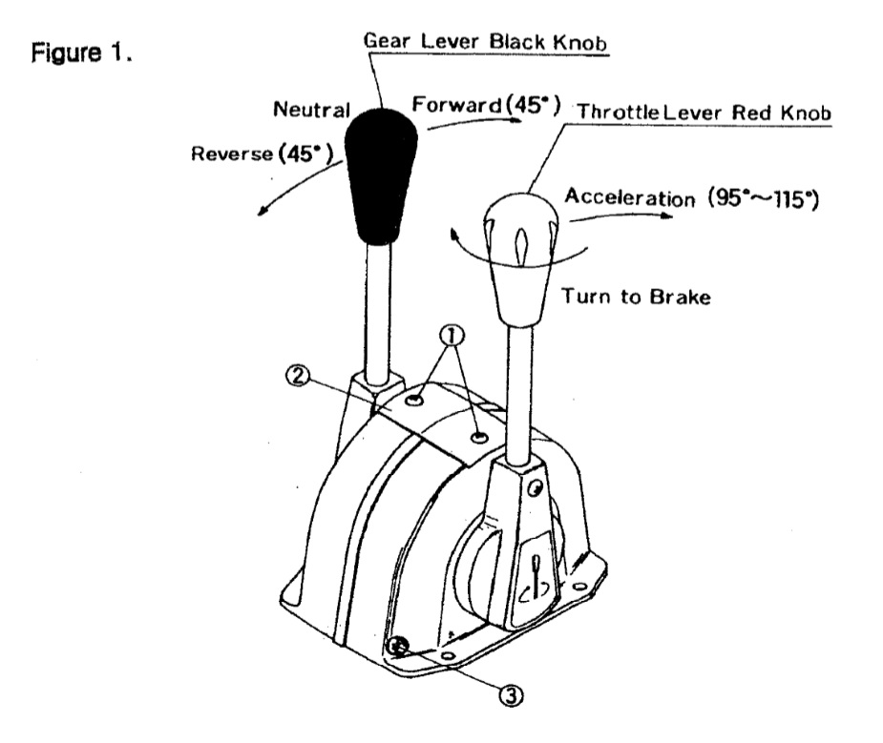
  NOTE : DO NOT INSTALL SCREWS
  - AND COVER PLATE
  - DO NOT SECURE THE CONTROL HEAD TO THE MOUNTING HOLE AT THIS STATE.
  NOTE : AVOID BENDING THE CABLE TH A RADIUS OF LESS THAN 200.0mm(8”).
  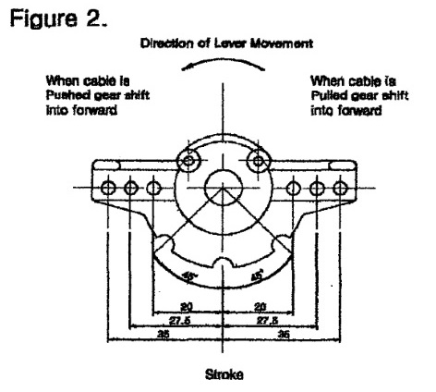
  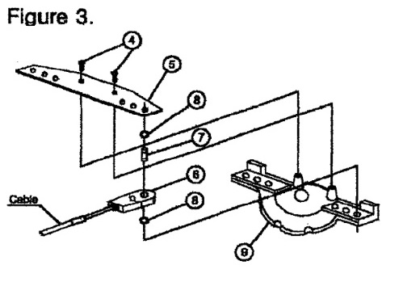
  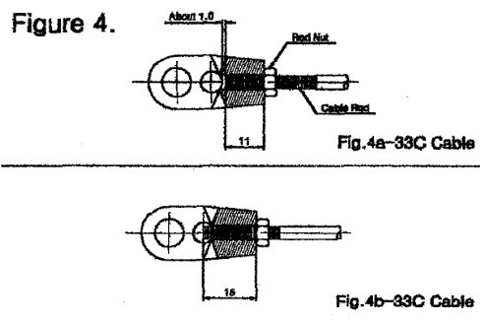
  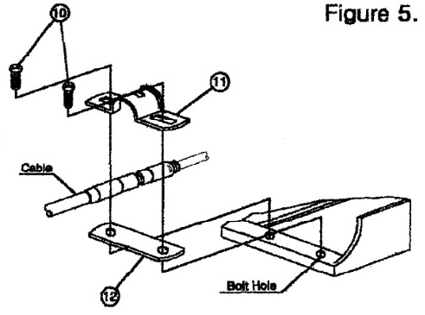
  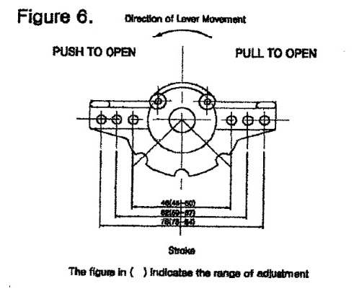
  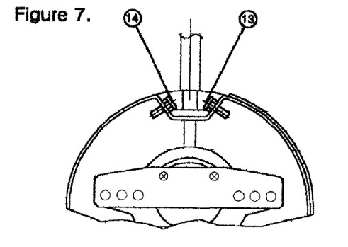

SINGLE LEVER INSTALLATION

The Singe Lever can be installed in the same manner as the Twin Lever. To install the Single Lever, just follow Step 1 through Step 8 on previous pages.

DUAL STATION INSTALLATION

The dual station (the system to control a single engine from two control heads installed separately) can be installed in the following three ways (A, B or C).

To install, first connect the main-control head to the engine and then connect the main control head to the sub-control head. This procedure applies to the three (A, B or C) ways of installation.

To install the dual station in A or B way, first remove the detent from the sub-control head. In the case of A, the attachment kit shown in Table 1 is required to. To install B or C way, consult the dealer from whom you purchased the control head.

The Table 1 applies to the 3C series cable. When the 4C series cable is used, consult the dealer from whom you purchased the control head.

Table 1 : Attachment Kit

For the use of 3C Cable
ITEM | CABLE ADAPTER KITS
SINGLE LEVER | PT 10113
TWIN LEVER | PT 20213

Table 2 : Attachment Kit and part No.

For the use of 4C Cable
ITEM | CABLE ADAPTER KITS
SINGLE LEVER | PT 10114
TWIN LEVER | PT 20214

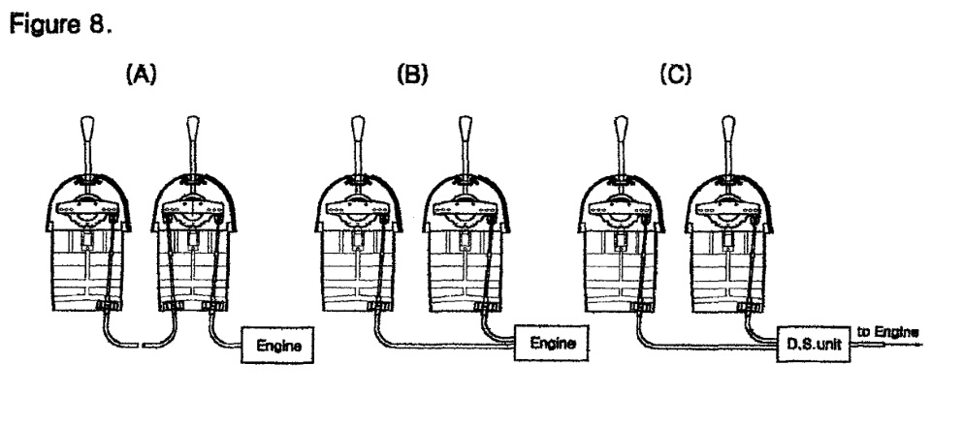
HOW TO CHANGE THE LEVER MOUNTING ANGLE

Remove the control head from the mounting hole, then place the lever in a vertical position and insert a 45.0 mm hexagon wrench into the hole in the housing flange.
Loosen the screw ⑮holding the lever to the shaft and then remove the lever.
Since the lever is fitted to the shaft by means of a spine, the lever angle can be easily changed. Be sure to tighten the screw ⑯securely after the lever is inserted in the desire position. ( See Figure 9)

ROUTINE CARE

To maintain a longer service life, routine care is most important, particularly when the control head is exposed to the salt water. Coating of wax, rust inhibitor, grease or oil will help keep the control head in good condition.

